EXNO:11 PL SQL PROGRAMS DATE:11.10.2024

NAME:M.Praveenraj

REG NO:230701396

PROGRAM 1

Write a PL/SQL block to calculate the incentive of an employee whose ID is 110.

DECLARE

incentive NUMBER; BEGIN

SELECT salary * 0.1 INTO incentive FROM employees

WHERE employee_id = 110;

DBMS_OUTPUT.PUT_LINE('Incentive for Employee 110: ' || incentive); END;

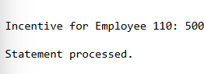

PROGRAM 2

Write a PL/SQL block to show an invalid case-insensitive reference to a quoted and without quoted user-defined identifier.

DECLARE

"MyVariable" NUMBER := 10; -- Quoted identifier (case-sensitive) myvariable NUMBER := 20; -- Unquoted identifier (case-insensitive)

BEGIN

DBMS_OUTPUT.PUT_LINE('Value of "MyVariable": ' || "MyVariable"); DBMS_OUTPUT.PUT_LINE('Value of myvariable: ' || myvariable);

-- Attempting invalid case-insensitive reference

DBMS_OUTPUT.PUT_LINE('Incorrect reference to "MyVariable": ' || myVariable); -- This will cause an error

EXCEPTION

WHEN OTHERS THEN

DBMS_OUTPUT.PUT_LINE('An error occurred: ' || SQLERRM); END;

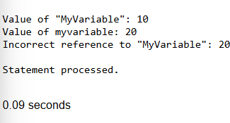

PROGRAM 3

Write a PL/SQL block to adjust the salary of the employee whose ID 122. Sample table: employees

BEGIN

UPDATE employees

SET salary = salary + 500 WHERE employee_id = 122;

COMMIT;

DBMS_OUTPUT.PUT_LINE('Salary updated for employee ID 122'); EXCEPTION

WHEN OTHERS THEN DBMS_OUTPUT.PUT_LINE('Error: ' || SQLERRM);

END;

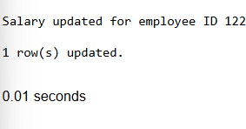

PROGRAM 4

Write a PL/SQL block to create a procedure using the "IS [NOT] NULL Operator" and show AND operator returns TRUE if and only if both operands are TRUE.

DECLARE

PROCEDURE check_values(v1 IN VARCHAR2, v2 IN VARCHAR2) IS BEGIN

IF v1 IS NOT NULL AND v2 IS NOT NULL THEN

DBMS_OUTPUT.PUT_LINE('Both values are NOT NULL. AND condition is TRUE.');

ELSE

DBMS_OUTPUT.PUT_LINE('AND condition is FALSE.'); END IF;

END;

BEGIN

-- Example call to the procedure

check_values('Hello', 'World'); -- Both values are not NULL check_values('Hello', NULL); -- One value is NULL

END;

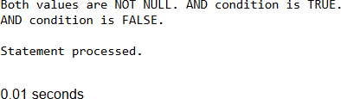

PROGRAM 5

Write a PL/SQL block to describe the usage of LIKE operator including wildcard characters and escape character.

DECLARE

v_text VARCHAR2(20) := '20% off'; BEGIN

IF v_text LIKE '20\%%' ESCAPE '\' THEN

DBMS_OUTPUT.PUT_LINE('Matches "20%" at the start'); ELSIF v_text LIKE '_0%' THEN

DBMS_OUTPUT.PUT_LINE('Second character is "0"'); END IF;

END;

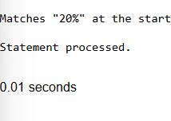

PROGRAM 6

Write a PL/SQL program to arrange the number of two variable in such a way that the small number will store in num_small variable and large number will store in num_large variable.

DECLARE

num1 NUMBER := 10; -- Example value num2 NUMBER := 20; -- Example value num_small NUMBER;

num_large NUMBER; BEGIN

IF num1 < num2 THEN num_small := num1; num_large := num2;

ELSE

num_small := num2; num_large := num1;

END IF;

DBMS_OUTPUT.PUT_LINE('Small number: ' || num_small); DBMS_OUTPUT.PUT_LINE('Large number: ' || num_large);

END;

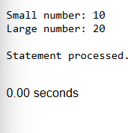

PROGRAM 7

Write a PL/SQL procedure to calculate the incentive on a target achieved and display the message either the record updated or not.

DECLARE

PROCEDURE calculate_incentive(target IN NUMBER, actual_sales IN NUMBER) IS incentive NUMBER;

BEGIN

IF actual_sales >= target THEN

incentive := actual_sales * 0.1; -- 10% incentive DBMS_OUTPUT.PUT_LINE('Record updated with incentive: ' || incentive);

ELSE

DBMS_OUTPUT.PUT_LINE('Record not updated. Target not achieved.'); END IF;

END; BEGIN

-- Example call to the procedure calculate_incentive(1000, 1200); -- Target achieved calculate_incentive(1000, 800); -- Target not achieved

END;

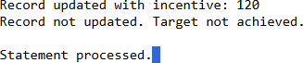

PROGRAM 8

Write a PL/SQL procedure to calculate incentive achieved according to the specific sale limit.

DECLARE

PROCEDURE calculate_incentive(sales IN NUMBER) IS incentive NUMBER;

BEGIN

IF sales >= 1000 THEN

incentive := sales * 0.1; -- 10% incentive for sales >= 1000 ELSIF sales >= 500 THEN

incentive := sales * 0.05; -- 5% incentive for sales >= 500 ELSE

incentive := 0; -- No incentive for sales < 500 END IF;

DBMS_OUTPUT.PUT_LINE('Incentive: ' || incentive); END;

BEGIN

-- Example calls

calculate_incentive(1200); -- High sales, 10% incentive calculate_incentive(600); -- Medium sales, 5% incentive calculate_incentive(400); -- Low sales, no incentive

END;

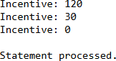

PROGRAM 9

Write a PL/SQL program to count number of employees in department 50 and check whether this department have any vacancies or not. There are 45 vacancies in this department.

DECLARE

emp_count NUMBER; vacancies NUMBER := 45;

BEGIN

-- Count the number of employees in department 50 SELECT COUNT(*) INTO emp_count

FROM employees

WHERE department_id = 50;

-- Check if there are vacancies IF emp_count < vacancies THEN

DBMS_OUTPUT.PUT_LINE('There are vacancies in department 50.'); ELSE

DBMS_OUTPUT.PUT_LINE('No vacancies in department 50.'); END IF;

END;

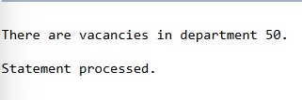

PROGRAM 10

Write a PL/SQL program to count number of employees in a specific department and check whether this department have any vacancies or not. If any vacancies, how many vacancies are in

that department.

DECLARE

dept_id NUMBER := 50; -- Example department ID

emp_count NUMBER;

total_vacancies NUMBER := 45; -- Total vacancies in the department vacancies NUMBER;

BEGIN

-- Count the number of employees in the specific department SELECT COUNT(*) INTO emp_count

FROM employees

WHERE department_id = dept_id;

-- Calculate vacancies based on total vacancies and current employees vacancies := total_vacancies - emp_count;

-- Check if there are vacancies IF vacancies > 0 THEN

DBMS_OUTPUT.PUT_LINE('There are ' || vacancies || ' vacancies in department ' || dept_id);

ELSE

DBMS_OUTPUT.PUT_LINE('No vacancies in department ' || dept_id); END IF;

END;

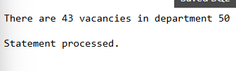

PROGRAM 11

Write a PL/SQL program to display the employee IDs, names, job titles, hire dates, and salaries of all employees.

BEGIN

FOR emp IN (SELECT employee_id, first_name, job_title, hire_date, salary FROM employees)

LOOP

DBMS_OUTPUT.PUT_LINE(emp.employee_id || ' ' || emp.first_name || ' ' || emp.job_title || ' ' || emp.hire_date || ' ' || emp.salary);

END LOOP; END;

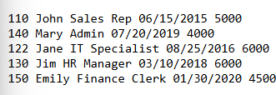

PROGRAM 12

Write a PL/SQL program to display the employee IDs, names, and department names of all Employees.

BEGIN

FOR emp IN (SELECT e.employee_id, e.first_name, d.department_name FROM employees e

JOIN departments d ON e.department_id = d.department_id)

LOOP

DBMS_OUTPUT.PUT_LINE('Employee ID: ' || emp.employee_id || ', Name: ' || emp.first_name ||

', Department: ' || emp.department_name);

END LOOP; END;

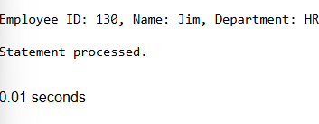

PROGRAM 13

Write a PL/SQL program to display the job IDs, titles, and minimum salaries of all jobs.

BEGIN

FOR job IN (SELECT job_id, job_title, min_salary FROM jobs)

LOOP

DBMS_OUTPUT.PUT_LINE('Job ID: ' || job.job_id || ', Title: ' || job.job_title ||

', Min Salary: ' || job.min_salary);

END LOOP; END;

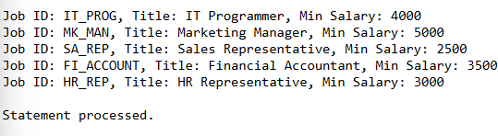

PROGRAM 14

Write a PL/SQL program to display the employee IDs, names, and job history start dates of all Employees.

BEGIN

FOR emp IN (SELECT e.employee_id, e.first_name, j.start_date FROM employees e

JOIN job_history j ON e.employee_id = j.employee_id)

LOOP

DBMS_OUTPUT.PUT_LINE('Employee ID: ' || emp.employee_id || ', Name: ' || emp.first_name ||

', Job History Start Date: ' || emp.start_date);

END LOOP; END;

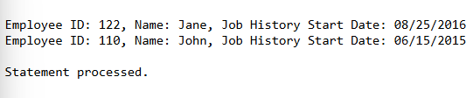

PROGRAM 15

Write a PL/SQL program to display the employee IDs, names, and job history end dates of all Employees.

BEGIN

FOR emp IN (SELECT e.employee_id, e.first_name, j.end_date FROM employees e

JOIN job_history j ON e.employee_id = j.employee_id)

LOOP

DBMS_OUTPUT.PUT_LINE('Employee ID: ' || emp.employee_id || ', Name: ' || emp.first_name ||

', Job History End Date: ' || emp.end_date);

END LOOP; END;

